**Head Jack Sparrow**

***Forensic***

**Challenge:**

Captain got an unknown image...Help him out and inspect the file.

Attached - Head_Jack_Sparrow.png

**Approach:**

We see this looks like a png file although we can’t open it :/

We open it up on a hex editor such as hexed.it and hmmm

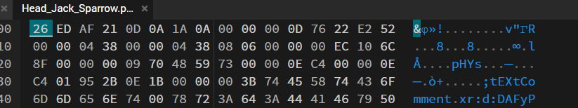

The file does not have the correct PNG headers.

I spent an unbelievable amount of time on this question, trying to analyze the bits and what not.

The solution?

We just replace the starting bytes with the correct bits for the PNG header:

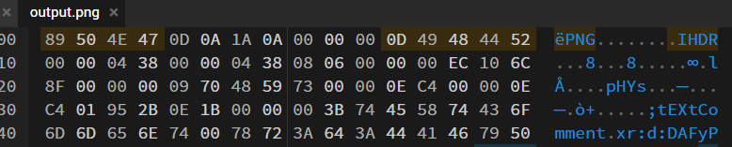

We save it and get an image.

Now the trickiest part, what to do with this image? I did what not trying to figure this out when I finally gave up and sent it to my teammate for him to work on it. AND THAT’S WHEN I NOTICED!

The flag was written at the bottom of the image :))

**Flag: QUESTCON{P1RaT3s_Ha13s_PNG_F1l3}**

Congrats!!

Happy Hacking!